# IST Admissions

# **SOFTWARE ENGINEERING**

# **DESIGN DOCUMENTATION**

# **DIET PLANNER**

# **ABDUL RAHIM – 210201097**

**INSTRUCTOR :**

# **MAM BENISH**

**SYSTEM DESIGN:**

System design in software engineering refers to the process of designing and developing a software system that satisfies the specified requirements. This process involves identifying and defining the components of the system, their interfaces, and the relationships between them. It also involves selecting appropriate design patterns and technologies, and ensuring that the system is scalable, maintainable, and secure.

**UML DIAGRAMS:**

UML (Unified Modeling Language) is a standardized general-purpose modeling language in the field of software engineering. UML diagrams are graphical representations of the structure and behavior of software systems, using a set of standardized symbols and notations. The main goal of UML is to provide a common language that can be used by software developers, business analysts, and other stakeholders to understand, design, and document the software systems being developed.

**• Activity diagram:**

Activity diagram is a type of UML (Unified Modeling Language) diagram that shows the flow of activities in a system. An activity diagram consists of a series of activities, each of which represents a task that is performed by the system. The activities are connected by arrows, which show the order in which the activities are performed.

This model stores the daily progress of the user activity diagram consists of a series of activities, each of which represents a task that is performed by the system. The activities are connected by arrows, which show the order in which the activities are performed.

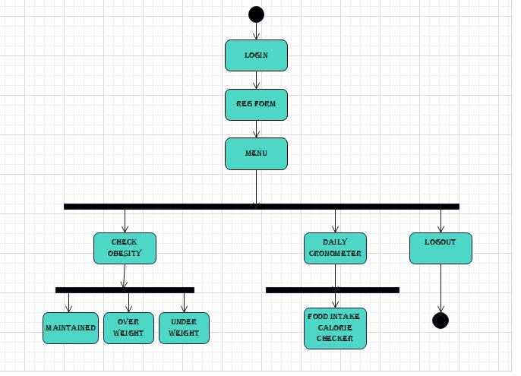

**• Sequence diagram:**

A sequence diagram is a type of UML (Unified Modeling Language) diagram that shows the interactions between objects in a system, including the messages that are exchanged between them and the order in which they occur.

A sequence diagram consists of a vertical timeline, with objects listed horizontally along the top of the diagram. The interactions between the objects are represented by horizontal arrows that show the messages being passed between the objects, with the order of the messages indicated by their position on the timeline.

• **CLASS DIAGRAMS:**

Class diagrams are a type of UML (Unified Modeling Language) diagram that show the structure and relationships of classes in a system. Class diagrams are used to model the static structure of a system, including the classes, their attributes (data members), and their operations (member functions).

Class diagrams can be used to represent the structure of a system at various levels of abstraction. For example, you might create a high-level class diagram that shows the main classes and their relationships, and then create more detailed class diagrams for individuals.

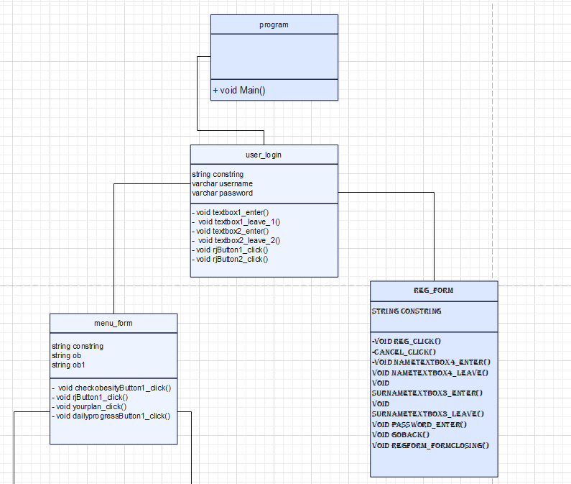

**• USE-CASE DIAGRAM:**

A use case diagram is a type of UML (Unified Modeling Language) diagram that shows the interactions between actors (users or systems) and the system being modeled. A use case represents a specific functionality or feature of the system, and the actors are the entities that interact with the system in order to use that functionality.

Use case diagrams are used to model the functional requirements of a system, and they can be used to identify the different actors that interact with the system and the various use cases that they perform.

This model stores the daily progress of the user calculates the calories which can be viewed later.

